**Government Polytechnic Pune**

(An Autonomous Institute Of Government Of Maharashtra)

**Department Of Computer Engineering**

(Academic Year 2013-14)



A Project Report On

**E-Salary System**

**… A Solution For Better Salary Transfer**

**Presented By : Guided By :**

**Jaydeep Mohite (1106105) Mrs. Archana S. Paike**

**Kalpesh Chaudhari (1106085)**

**Kalpesh Bhangre (1106083)**

**Government Polytechnic Pune**

(An Autonomous Institute Of Government Of Maharashtra)

**Department Of Computer Engineering**

(Academic Year 2013-14)



This is to certify that,

**Jaydeep Mohite 1106105**

**Kalpesh Chaudhari 1106085**

**Kalpesh Bhangre 1106083**

has successfully the necessary project work and prepared the report on

**“E-Salary Systems”**

in a satisfactory manner as partial fulfilment for the requirement of the Department of

Computer Engineering for the Academic Year 2013-14.

**Mrs. Archana S. Paike** **Mr. Umesh Kokate Mr. P. V. Sarode**

Project Guide HoD Principal

**Acknowledgement**

**I** would like to express my deep gratitude towards my project guide **Mrs. Archana S. Paike** for his able guidance and supervision which helped me for starting this project. I am extremely grateful and remain indebted to him for being a source of inspiration and for his constant support in the idea and starting of the project.

I am thankful to him for his constant constructive criticism and invaluable suggestions, which benefited me a lot while starting the project on. **‘E-Salary Systems’** would also like to thank our Head of Department **Mr. Umesh Kokate.** Who where directly and indirectly instrument in enabling me to stay committed for the project. I am also very much thankful to our Principle **Mr. P. V. Sarode.** I am also very much thankful to my parents and other family members for being such a great source of inspiration of mine.

Yours Thankful,

**Jaydeep Mohite**

**Kalpesh Chaudhari**

**Kalpesh Bhangre**

**Abstract**

Now-a-days, the salaries of primary, secondary and higher secondary teachers are done offline. That means the schools have to generate manual payroll slip and send it by post or by hand to Pay-unit or salary generating organization. So it takes a lot of time in doing all this stuff. So the primary goal of our project is to develop a web-site for pay-unit or organization where all the schools along with teachers can register here and their salaries can be made online without any delay.

Our project basically includes a web-site which has options for school and teacher registration. The job of manual payroll generation has been simplified in our project using computerized payroll generator. In addition to this, project also includes bank details of a teacher which will used in transferring the salary at first of any month. Basically we will use spiral process model for incrementing efficiency of a project. As a result, we all group partners will able to perform all the phases in project development at least once.

Hope, this project will prove to be very useful in today’s world of fast growing and developing in the field of Computer and Information Technology and will satisfy our motto…

**“… A Solution For Better Salary Transfer”**

|  |  |  |  |
| --- | --- | --- | --- |
| **CHAPTER** | **TITLE** | | **PAGE NO.** |
| **1** | **INTRODUCTION** | | **1** |
|  | 1.1 | WHAT IS PAYROLL AND E-SALARY SYSTEMS? | 1 |
| **2** | **MOTIVATION AND BACKGROUND** | | **2** |
|  | 2.1 | EXISTING SYSTEM | 2 |
| 2.2 | OUR SYSTEM AND ITS FEATURES | 3 |
| **3** | **PROJECT REQUIREMENTS** | | **4** |
|  | 3.1 | HARDWARE REQUIREMENTS | 4 |
| 3.2 | SOFTWARE REQUIREMENTS | 4 |
| 3.3 | FEASIBILITY STUDY | 5 |
| **4** | **DIAGRAMS** | | **7** |
|  | 4.1 | USE CASE DIAGRAM | 7 |
| 4.2 | ENTITY REALTIONSHIP DIAGRAM | 8 |
| 4.3 | DATA FLOW DIAGRAM | 9 |
| 4.4 | ACTIVITY DIAGRAM | 12 |
| **5** | **DATA DICTIONARY** | | **15** |
| **6** | **PROJECT SNAPSHOTS** | | **19** |
| **7** | **FUTURE SCOPE** | | **26** |
| **8** | **CONCLUSION** | | **27** |
| **9** | **REFERENCES** | | **28** |

**Contents**

1. **Introduction**
   1. **What is Payroll and E-Salary System?**

Our Project, The Payroll And E-Salary Systems, is basically a online wensite system which will help the to make the process of salary transfer easier. Our project is limited to making salaries of the government school teacher’s in a simple, quick, safe and time-bound way.

The payroll includes the details of the particular school teacher such as the his/her basic salary, his/her deductions and overall details associated with the salary systems of an organization. The E-salary Systems is associated with transferring the salaries according to the payroll calculated to his/her bank account directly and online through secure transaction.

1. **Motivation And Background**

**2.1 Existing System**

According to our study, the current system of salary transfer is the pune division is through manual check transfers. The school first creates the pay slip and sends it by hand to the pay unit office. The payunit office the receives manual slip checks it, and then sends it to the administration department to create the check.

**Drawbacks :**

The drawbacks of current system are that as it is a manual way of processing, it takes time. Moreover, there are a lot of chances that the slip maybe misplaces by the one who is carrying it to the pay unit office. Also, at the payunit office, the government officials are not as duty oriented as other. To overcome to all these drawbacks it was necessary to develop a more efficient and secure.

**2.2 Our System and Its Features**

We have developed a system, which overcomes almost all the drawbacks of the current manual system. The main key points and features of our system are as follows:

* A system for Government Schools
* Automatic Payroll Slip Generator
* Online Salary Transfer To Specified Teacher’s Bank Account
* Teacher Salary Reports
* School Profiles

* Teacher Profiles
* Email Acknowledgement to Salary Transfer Process

**3. Project Requirements**

**3.1 Hardware Requirements (Server)**

* Processor Dual Core 733Mhz and above
* Ram 1 GB recommended
* Hard Disk Space 1GB
* Internet Connection

**3.2 Software Requirements**

* Internet Explorer 8.0 Above
* Mozilla Firefox 11 and above
* Chrome Browser 11 and above

**3.3 Tools and Programming Languages used**

* Apache Tomcat Server 7.0.2
* JavaServerPages (JSP)
* HTML
* JavaScript
* Ajax
* CSS and CSS3
* Oracle Database 11g
* jQuery

**3.2 Feasibility Study**

* **What are the user’s demonstrable needs?**

The user wants a web-based system, which will reduce the bulk of paperwork, provide ease of work, flexibility, fast record finding,modifying, adding, removing and generating the reports.

* **How can the problem be redefined?**

We tallied the problems and needs by existing system and requirements. We were further updating in the layout in the basis of redefined the problems. In feasibility study phase we had undergone through various steps, which are described as under:

How feasible is the system proposed?

This was analyzed by comparing the following factors with both the existing system and proposed system.

1. **Cost**

The cost required in the proposed system is comparatively less to the existing system.

1. **Effort**

Compared to the existing system the proposed system will provide a better working environment in which their will be ease of work and the effort required will be comparatively less than the existing system.

1. **Time**

The time required to make overall process of salary transfer is achieved early than the previous system.

1. **Labor**

In the existing system the number of staff required for completing the work is more while the new system will require quite less number of staff.

**4. Diagrams**

**4.1 Use Case Diagram**

School

Admin

Teacher

Fig. 4.1 Use Case Diagram

**4.2 Entity Relationship Diagram**

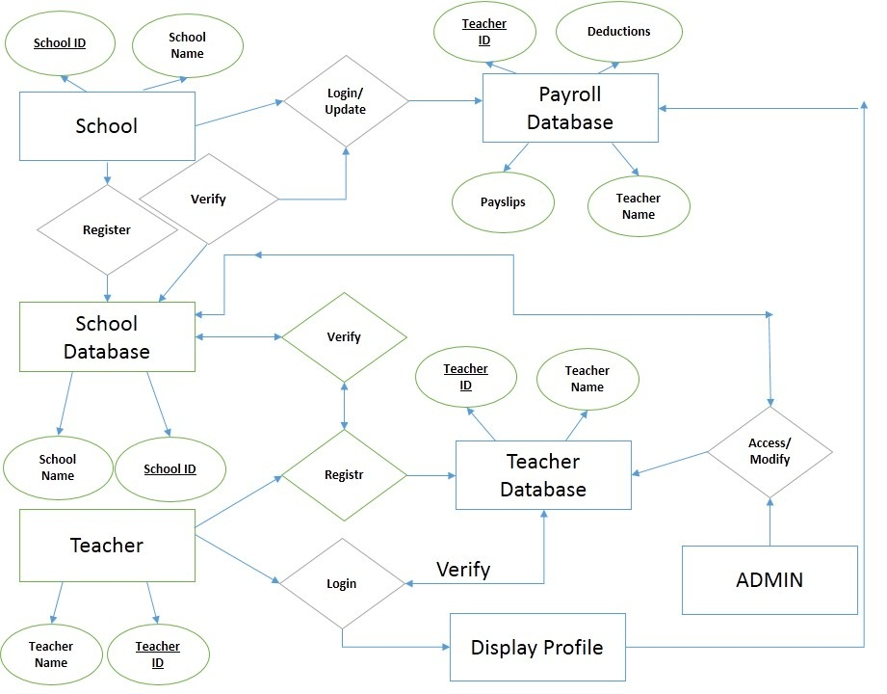

Fig. 4.2 ER Diagram

**4.3 Data Flow Diagram**

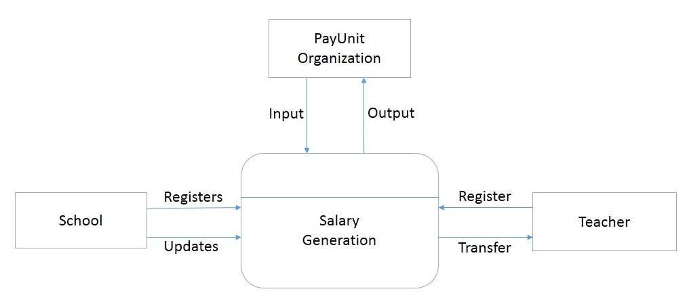

Fig. 4.3.1 Context Diagram

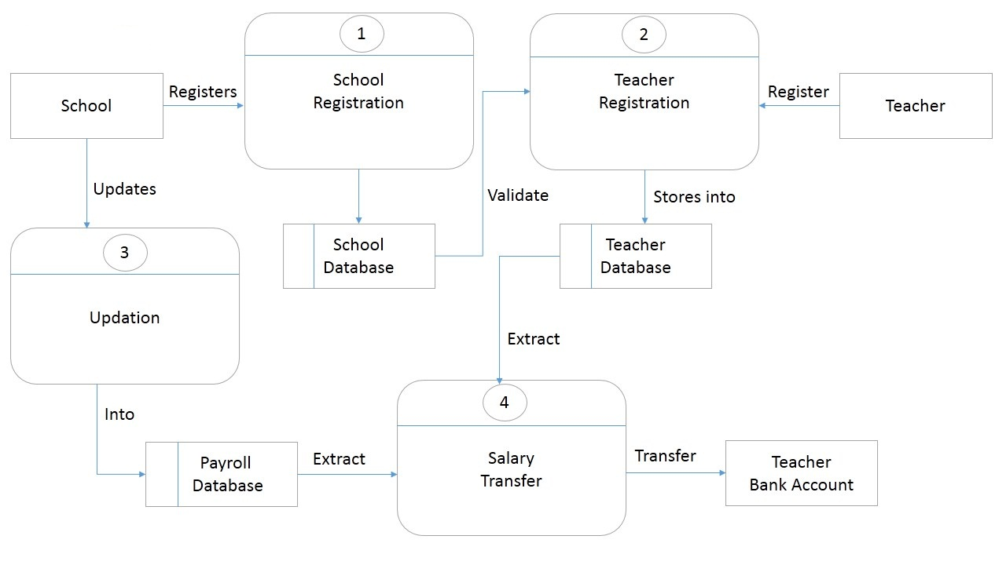

Fig. 4.3.2 Level 0 Diagram

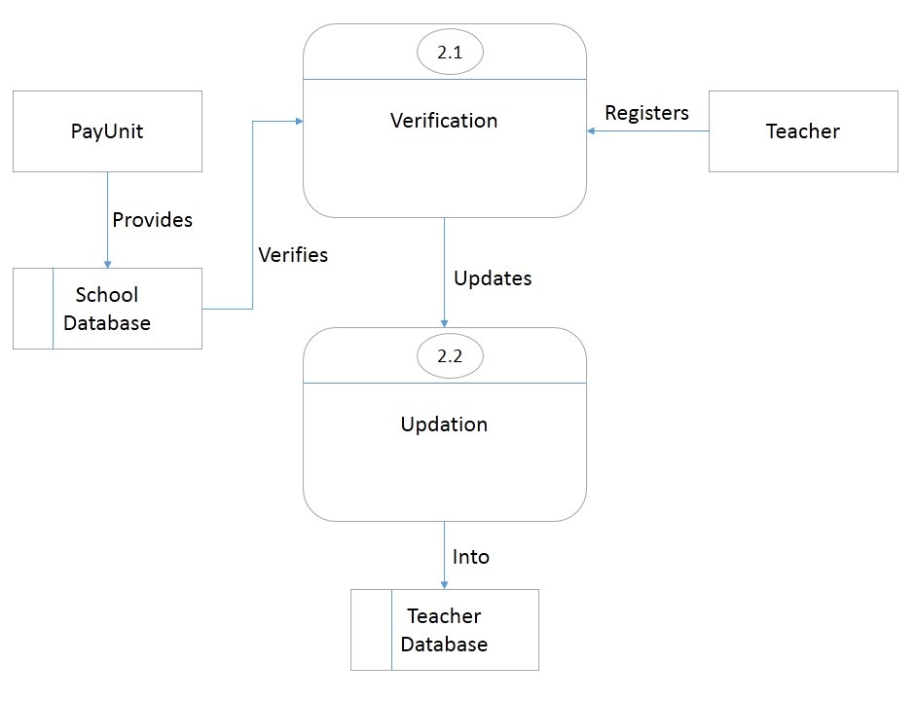

Fig. 4.3.3 Level 2 Diagram

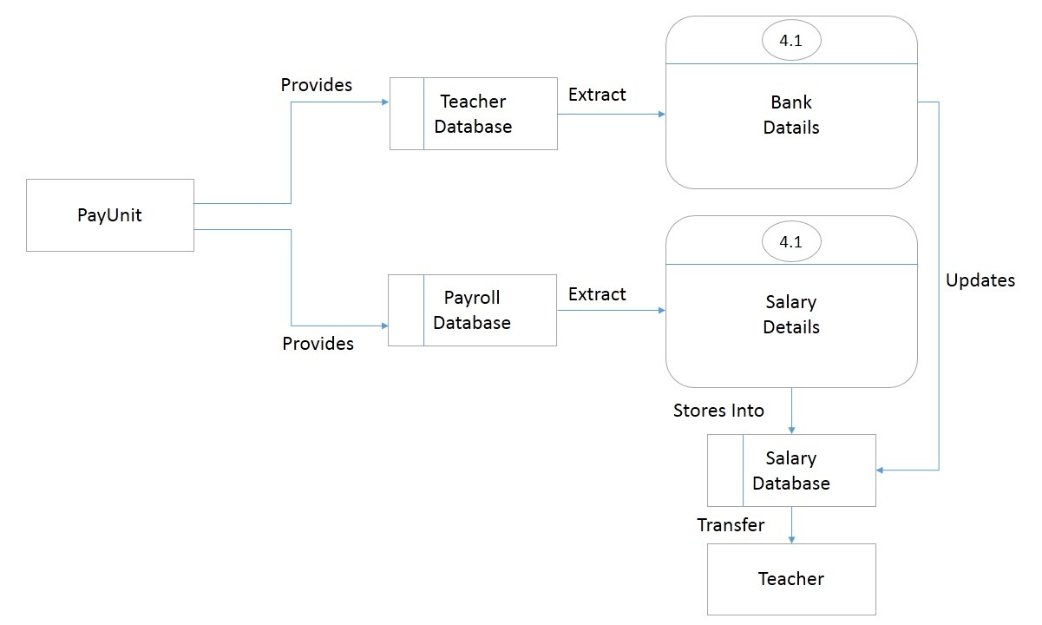

Fig. 4.3.4 Level 4 Diagram

**4.4 Activity Diagram**

**Database**

**Logout**

**Final**

**Salary**

**Reports**

**Administrator**

View Generate Generate Transfer

Reports Database Salary Salary

**Salary To**

**Account**

Fig. 4.4.1 Administrator Activity Diagram

**Logout**

**Reports**

**School**

Registers Submit Add Delete Upload

Staff Teacher Teacher Salary

Details Database

**Submit Salary**

**Database**

**Submit , Manipulate**

**Teacher Details**

Fig. 4.4.2 School Activity Diagram

**Teacher**

**Logout**

**View Status**

**View Payroll Slip**

**Registration Process**

Register Salary Salary

Report Transfer

Status

Fig. 4.4.3 Teacher Activity Diagram

**5. Data Dictionary**

**5.1 school_login**

|  |  |  |  |  |  |  |  |
| --- | --- | --- | --- | --- | --- | --- | --- |
| **Table** | **Column** | **Data Type** | **Length** | **Precision** | **Scale** | **Primary Key** | **Nullable** |
| [SCHOOL_LOGIN](javascript:ret_Column('PAYROLL.SCHOOL_LOGIN');) | [S_ID](javascript:ret_Column('S_ID');) | NUMBER | 22 | - | - | - | nullable |
|  | [S_USERNAME](javascript:ret_Column('S_USERNAME');) | VARCHAR2 | 100 | - | - | - | nullable |
|  | [S_PASSWORD](javascript:ret_Column('S_PASSWORD');) | VARCHAR2 | 100 | - | - | - | nullable |
|  | [QUESTION](javascript:ret_Column('QUESTION');) | VARCHAR2 | 100 | - | - | - | nullable |
|  | [ANSWER](javascript:ret_Column('ANSWER');) | VARCHAR2 | 100 | - | - | - | nullable |

**5.2 school_details**

|  |  |  |  |  |  |  |  |
| --- | --- | --- | --- | --- | --- | --- | --- |
| **Table** | **Column** | **Data Type** | **Length** | **Precision** | **Scale** | **Primary Key** | **Nullable** |
| [SCHOOL_DETAILS](javascript:ret_Column('PAYROLL.SCHOOL_DETAILS');) | [S_ID](javascript:ret_Column('S_ID');) | NUMBER | 22 | - | 0 | 1 | - |
|  | [S_NAME](javascript:ret_Column('S_NAME');) | VARCHAR2 | 100 | - | - | - | nullable |
|  | [S_RID](javascript:ret_Column('S_RID');) | VARCHAR2 | 100 | - | - | - | nullable |
|  | [S_TYPE](javascript:ret_Column('S_TYPE');) | VARCHAR2 | 20 | - | - | - | nullable |
|  | [S_ADD1](javascript:ret_Column('S_ADD1');) | VARCHAR2 | 100 | - | - | - | nullable |
|  | [S_CITY](javascript:ret_Column('S_CITY');) | VARCHAR2 | 100 | - | - | - | nullable |
|  | [S_TALUKA](javascript:ret_Column('S_TALUKA');) | VARCHAR2 | 100 | - | - | - | nullable |
|  | [S_DISTRICT](javascript:ret_Column('S_DISTRICT');) | VARCHAR2 | 100 | - | - | - | nullable |
|  | [S_STATE](javascript:ret_Column('S_STATE');) | VARCHAR2 | 100 | - | - | - | nullable |
|  | [S_PINCODE](javascript:ret_Column('S_PINCODE');) | NUMBER | 22 | - | - | - | nullable |
|  | [S_SAREA](javascript:ret_Column('S_SAREA');) | FLOAT | 126 | 126 | - | - | nullable |
|  | [S_CLASSROOMS](javascript:ret_Column('S_CLASSROOMS');) | NUMBER | 22 | - | 0 | - | nullable |
|  | [S_PAREA](javascript:ret_Column('S_PAREA');) | FLOAT | 126 | 126 | - | - | nullable |
|  | [S_SANITARY](javascript:ret_Column('S_SANITARY');) | VARCHAR2 | 10 | - | - | - | nullable |
|  | [S_DRINKING](javascript:ret_Column('S_DRINKING');) | VARCHAR2 | 10 | - | - | - | nullable |
|  | [S_TSTAFF](javascript:ret_Column('S_TSTAFF');) | NUMBER | 22 | - | - | - | nullable |
|  | [T_CONTACT](javascript:ret_Column('T_CONTACT');) | NUMBER | 22 | - | - | - | nullable |
|  | [T_EMAIL](javascript:ret_Column('T_EMAIL');) | VARCHAR2 | 100 | - | - | - | nullable |

**5.3 teacher_login**

|  |  |  |  |  |  |  |  |
| --- | --- | --- | --- | --- | --- | --- | --- |
| **Table** | **Column** | **Data Type** | **Length** | **Precision** | **Scale** | **Primary Key** | **Nullable** |
| [TEACHER_LOGIN](javascript:ret_Column('PAYROLL.TEACHER_LOGIN');) | [T_ID](javascript:ret_Column('T_ID');) | NUMBER | 22 | - | - | - | nullable |
|  | [T_USERNAME](javascript:ret_Column('T_USERNAME');) | VARCHAR2 | 100 | - | - | - | nullable |
|  | [T_PASSWORD](javascript:ret_Column('T_PASSWORD');) | VARCHAR2 | 100 | - | - | - | nullable |
|  | [QUESTION](javascript:ret_Column('QUESTION');) | VARCHAR2 | 100 | - | - | - | nullable |
|  | [ANSWER](javascript:ret_Column('ANSWER');) | VARCHAR2 | 100 | - | - | - | nullable |

**5.4 teacher_details**

|  |  |  |  |  |  |  |  |
| --- | --- | --- | --- | --- | --- | --- | --- |
| **Table** | **Column** | **Data Type** | **Length** | **Precision** | **Scale** | **Primary Key** | **Nullable** |
| [TEACHER_DETAILS](javascript:ret_Column('PAYROLL.TEACHER_DETAILS');) | [T_ID](javascript:ret_Column('T_ID');) | NUMBER | 22 | - | - | 1 | - |
|  | [T_NAME](javascript:ret_Column('T_NAME');) | VARCHAR2 | 100 | - | - | - | nullable |
|  | [T_RID](javascript:ret_Column('T_RID');) | VARCHAR2 | 100 | - | - | - | nullable |
|  | [T_SCHOOL](javascript:ret_Column('T_SCHOOL');) | VARCHAR2 | 100 | - | - | - | nullable |
|  | [T_ADD1](javascript:ret_Column('T_ADD1');) | VARCHAR2 | 100 | - | - | - | nullable |
|  | [T_CITY](javascript:ret_Column('T_CITY');) | VARCHAR2 | 50 | - | - | - | nullable |
|  | [T_TALUKA](javascript:ret_Column('T_TALUKA');) | VARCHAR2 | 100 | - | - | - | nullable |
|  | [T_DISTRICT](javascript:ret_Column('T_DISTRICT');) | VARCHAR2 | 100 | - | - | - | nullable |
|  | [T_STATE](javascript:ret_Column('T_STATE');) | VARCHAR2 | 100 | - | - | - | nullable |
|  | [T_PINCODE](javascript:ret_Column('T_PINCODE');) | NUMBER | 22 | - | - | - | nullable |
|  | [T_TYPE](javascript:ret_Column('T_TYPE');) | VARCHAR2 | 100 | - | - | - | nullable |
|  | [T_CERT](javascript:ret_Column('T_CERT');) | VARCHAR2 | 100 | - | - | - | nullable |
|  | [T_PYEAR](javascript:ret_Column('T_PYEAR');) | NUMBER | 22 | - | - | - | nullable |
|  | [T_JDATE](javascript:ret_Column('T_JDATE');) | VARCHAR2 | 100 | - | - | - | nullable |
|  | [T_BANK](javascript:ret_Column('T_BANK');) | VARCHAR2 | 100 | - | - | - | nullable |
|  | [T_BRANCH](javascript:ret_Column('T_BRANCH');) | VARCHAR2 | 100 | - | - | - | nullable |
|  | [T_ACCOUNT](javascript:ret_Column('T_ACCOUNT');) | NUMBER | 22 | - | - | - | nullable |
|  | [S_ID](javascript:ret_Column('S_ID');) | NUMBER | 22 | - | - | - | nullable |
|  | [T_EMAIL](javascript:ret_Column('T_EMAIL');) | VARCHAR2 | 100 | - | - | - | nullable |

**5.4 salary_details**

|  |  |  |  |  |  |  |  |
| --- | --- | --- | --- | --- | --- | --- | --- |
| **Table** | **Column** | **Data Type** | **Length** | **Precision** | **Scale** | **Primary Key** | **Nullable** |
| [SALARY_DETAILS](javascript:ret_Column('PAYROLL.SALARY_DETAILS');) | [S_RID](javascript:ret_Column('S_RID');) | VARCHAR2 | 50 | - | - | - | nullable |
|  | [T_RID](javascript:ret_Column('T_RID');) | VARCHAR2 | 100 | - | - | - | nullable |
|  | [T_NAME](javascript:ret_Column('T_NAME');) | VARCHAR2 | 100 | - | - | - | nullable |
|  | [BAND_PAY](javascript:ret_Column('BAND_PAY');) | FLOAT | 126 | 126 | - | - | nullable |
|  | [GRADE_PAY](javascript:ret_Column('GRADE_PAY');) | FLOAT | 126 | 126 | - | - | nullable |
|  | [SUM_BAND_GRADE](javascript:ret_Column('SUM_BAND_GRADE');) | FLOAT | 126 | 126 | - | - | nullable |
|  | [DA](javascript:ret_Column('DA');) | VARCHAR2 | 100 | - | - | - | nullable |
|  | [HRA](javascript:ret_Column('HRA');) | VARCHAR2 | 100 | - | - | - | nullable |
|  | [TA](javascript:ret_Column('TA');) | FLOAT | 126 | 126 | - | - | nullable |
|  | [RECOVERY](javascript:ret_Column('RECOVERY');) | FLOAT | 126 | 126 | - | - | nullable |
|  | [PPF](javascript:ret_Column('PPF');) | FLOAT | 126 | 126 | - | - | nullable |
|  | [PRO_TAX](javascript:ret_Column('PRO_TAX');) | FLOAT | 126 | 126 | - | - | nullable |
|  | [INCOME_TAX](javascript:ret_Column('INCOME_TAX');) | FLOAT | 126 | 126 | - | - | nullable |
|  | [TOTAL_SAL](javascript:ret_Column('TOTAL_SAL');) | FLOAT | 126 | 126 | - | - | nullable |

**5.5 MonthYear**

|  |  |  |  |  |  |  |  |
| --- | --- | --- | --- | --- | --- | --- | --- |
| **Table** | **Column** | **Data Type** | **Length** | **Precision** | **Scale** | **Primary Key** | **Nullable** |
| [MARCH2014](javascript:ret_Column('PAYROLL.MARCH2014');) | [T_RID](javascript:ret_Column('T_RID');) | VARCHAR2 | 50 | - | - | - | nullable |
|  | [STATUS](javascript:ret_Column('STATUS');) | VARCHAR2 | 50 | - | - | - | nullable |
|  |  |  |  |  |  |  |  |

**5.6 admin_login**

|  |  |  |  |  |  |  |  |
| --- | --- | --- | --- | --- | --- | --- | --- |
| **Table** | **Column** | **Data Type** | **Length** | **Precision** | **Scale** | **Primary Key** | **Nullable** |
| [ADMIN_LOGIN](javascript:ret_Column('PAYROLL.ADMIN_LOGIN');) | [A_ID](javascript:ret_Column('A_ID');) | NUMBER | 22 | - | - | - | nullable |
|  | [A_USERNAME](javascript:ret_Column('A_USERNAME');) | VARCHAR2 | 100 | - | - | - | nullable |
|  | [A_PASSWORD](javascript:ret_Column('A_PASSWORD');) | VARCHAR2 | 100 | - | - | - | nullable |
|  |  |  |  |  |  |  |  |

**5.7 feedback_details**

|  |  |  |  |  |  |  |  |
| --- | --- | --- | --- | --- | --- | --- | --- |
| **Table** | **Column** | **Data Type** | **Length** | **Precision** | **Scale** | **Primary Key** | **Nullable** |
| [FEEDBACK_DETAILS](javascript:ret_Column('PAYROLL.FEEDBACK_DETAILS');) | [F_ID](javascript:ret_Column('F_ID');) | NUMBER | 22 | - | - | - | nullable |
|  | [FEEDBACK](javascript:ret_Column('FEEDBACK');) | VARCHAR2 | 1000 | - | - | - | nullable |
|  | [EMAIL](javascript:ret_Column('EMAIL');) | VARCHAR2 | 50 | - | - | - | nullable |
|  |  |  |  |  |  |  |  |

**6. Project Snapshots**

**6.1 Homepage**

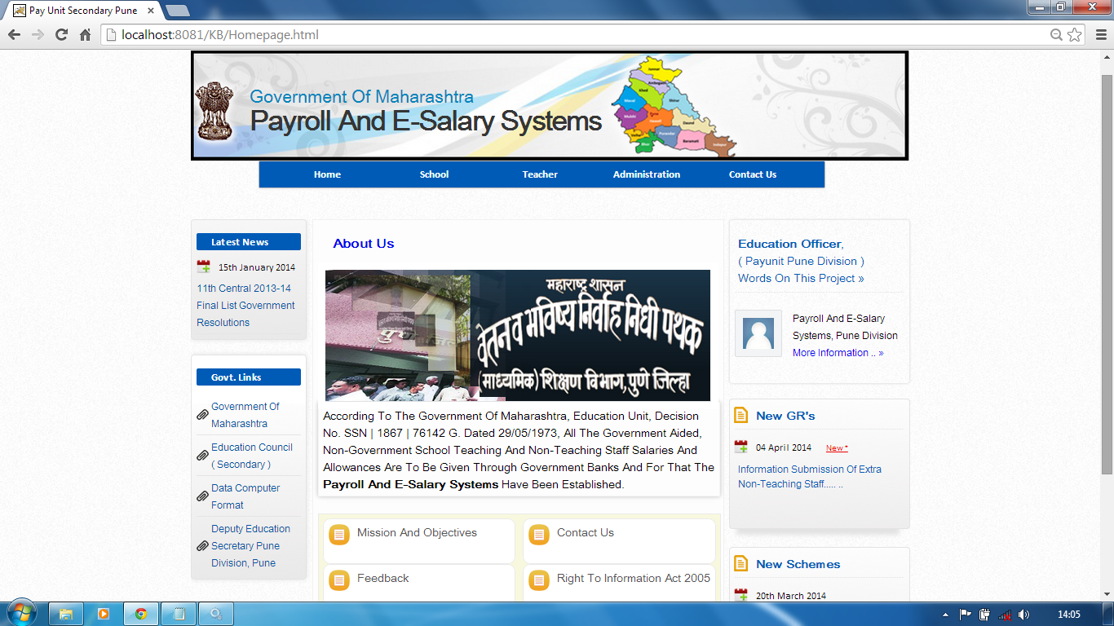

**2.2 Mission And Objectives**

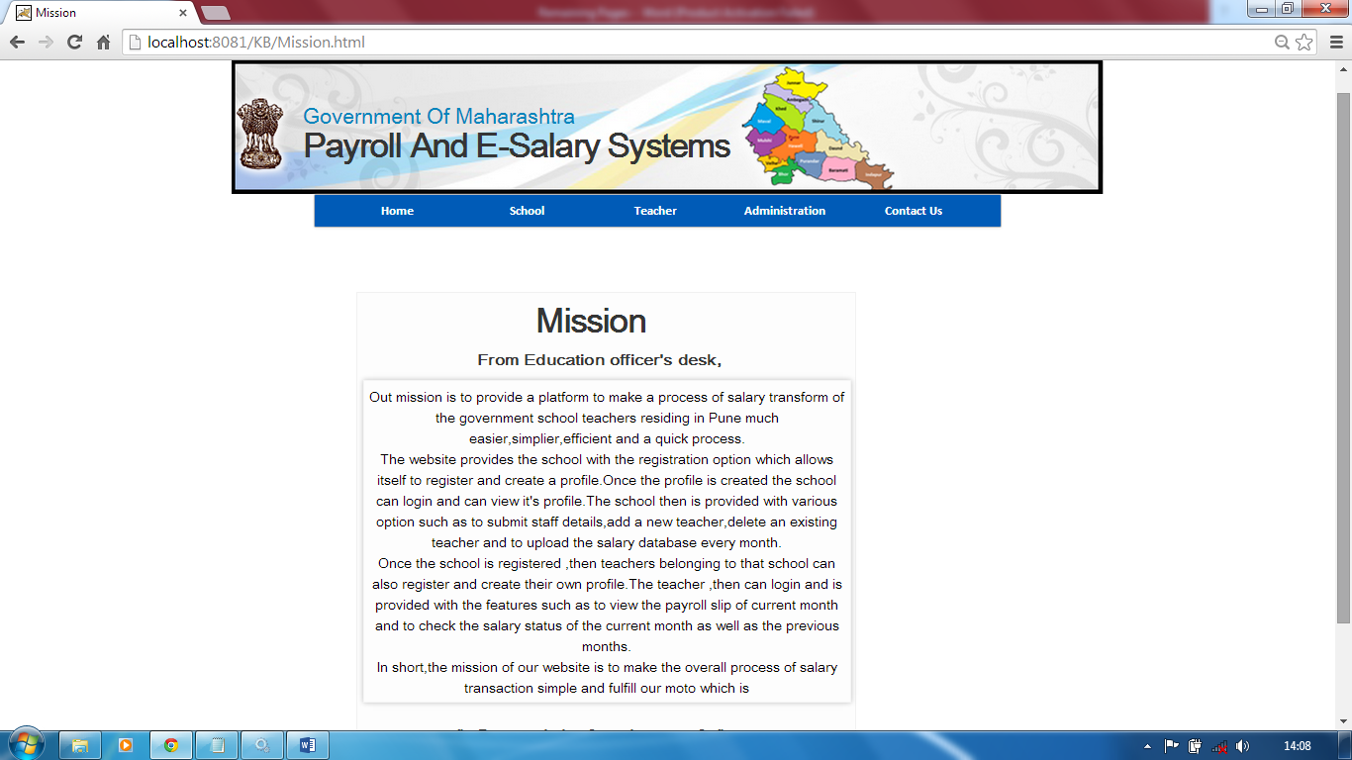

**6.3 School Login**

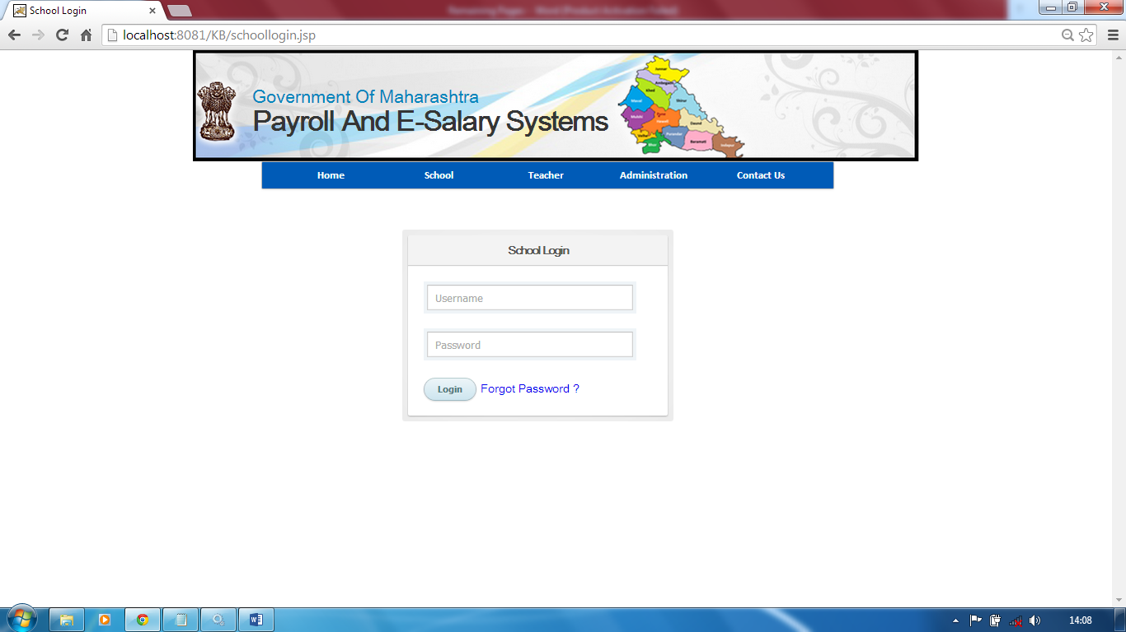

**6.4 Teacher Login**

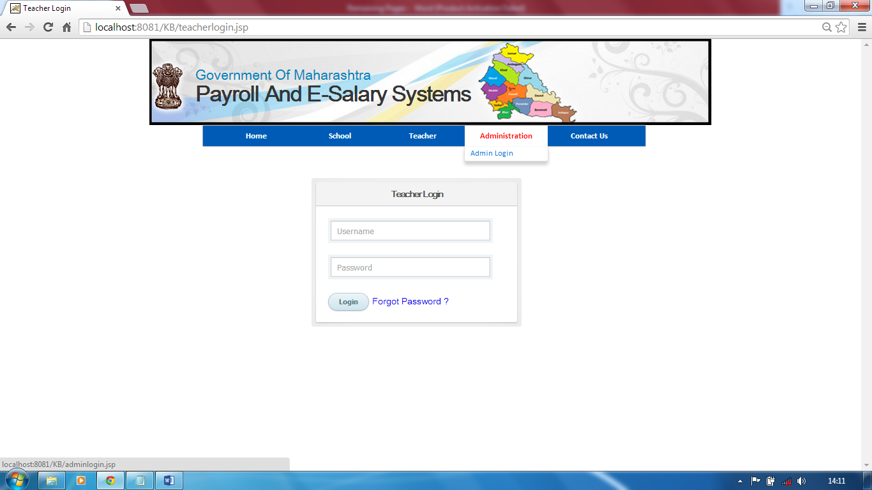

**6.5 Teacher Registration (Verification)**

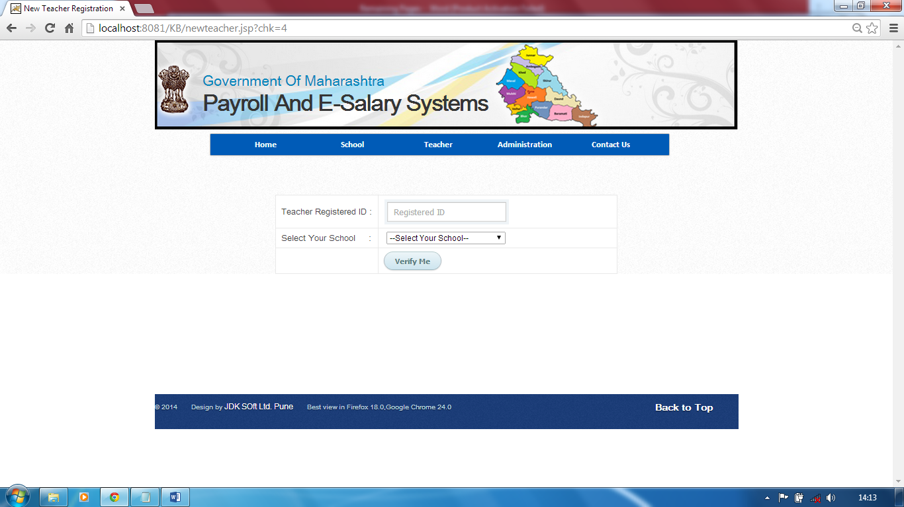

**6.6 Teacher Registration**

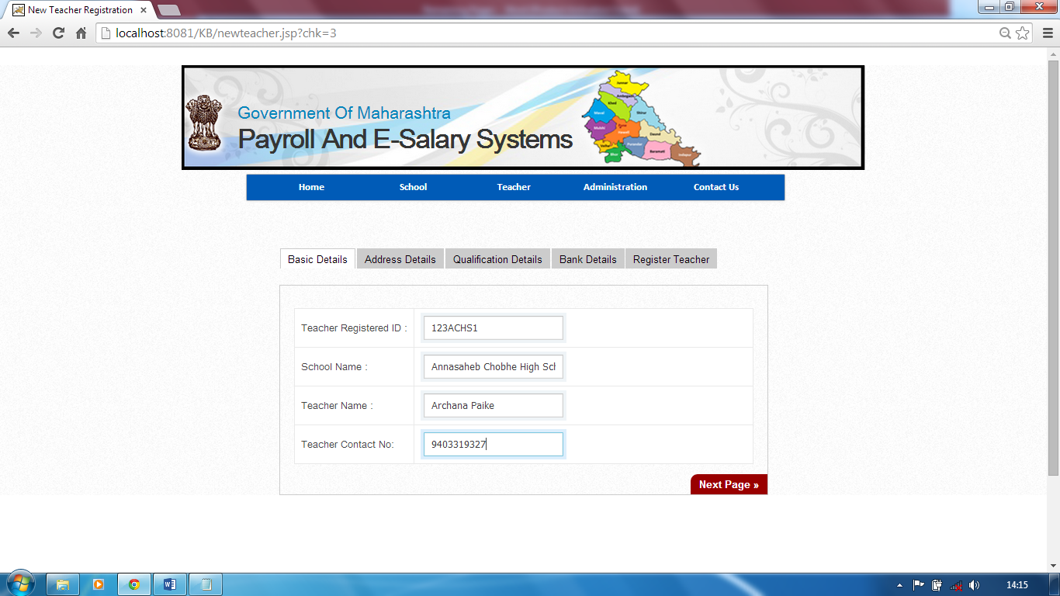

**6.7 School Homepage**

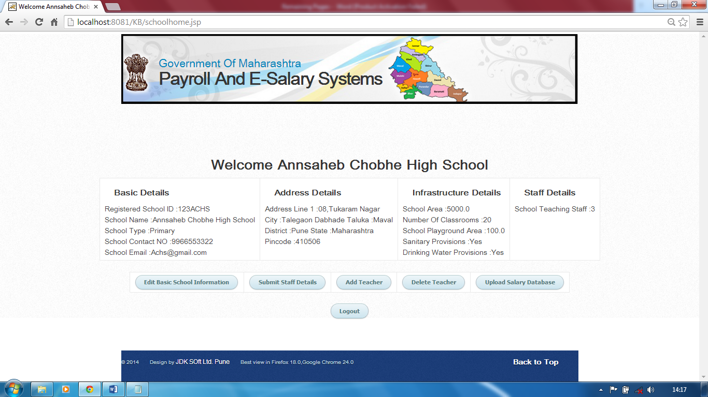

**6.8 Teacher Homepage**

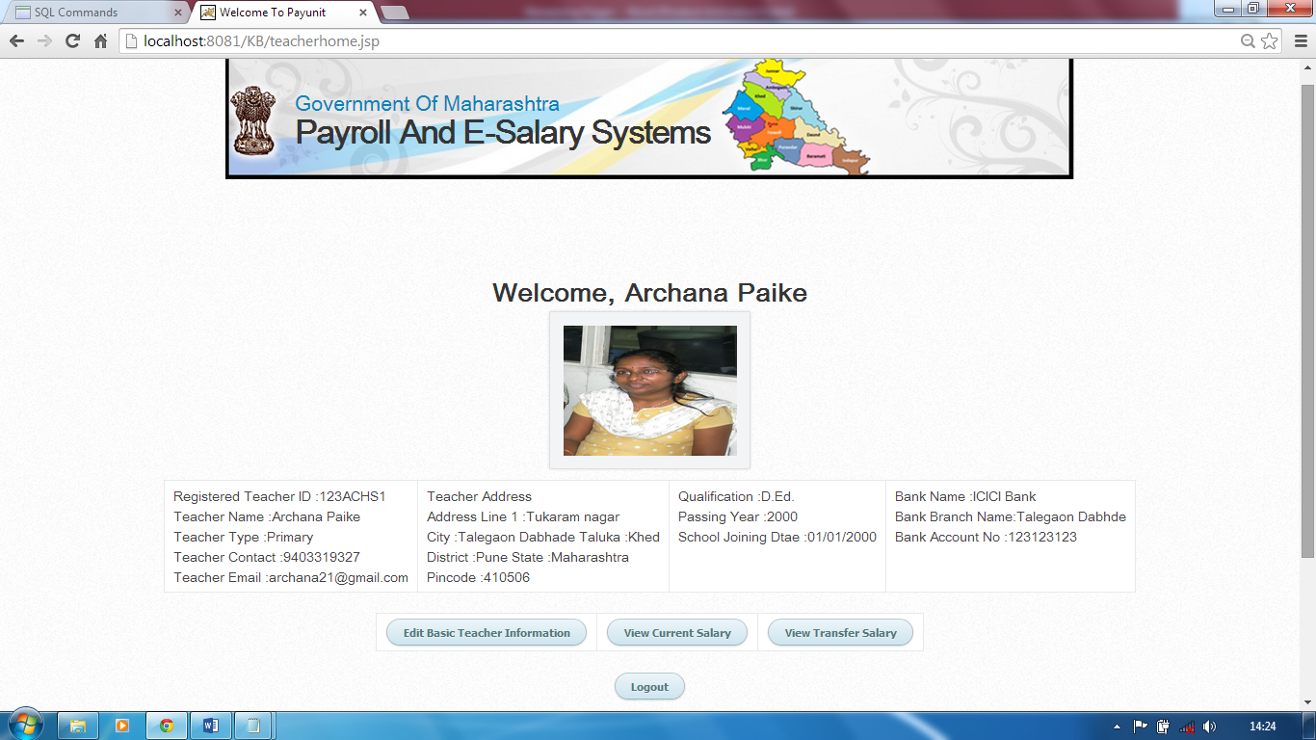

**6.9 Admin Homepage**

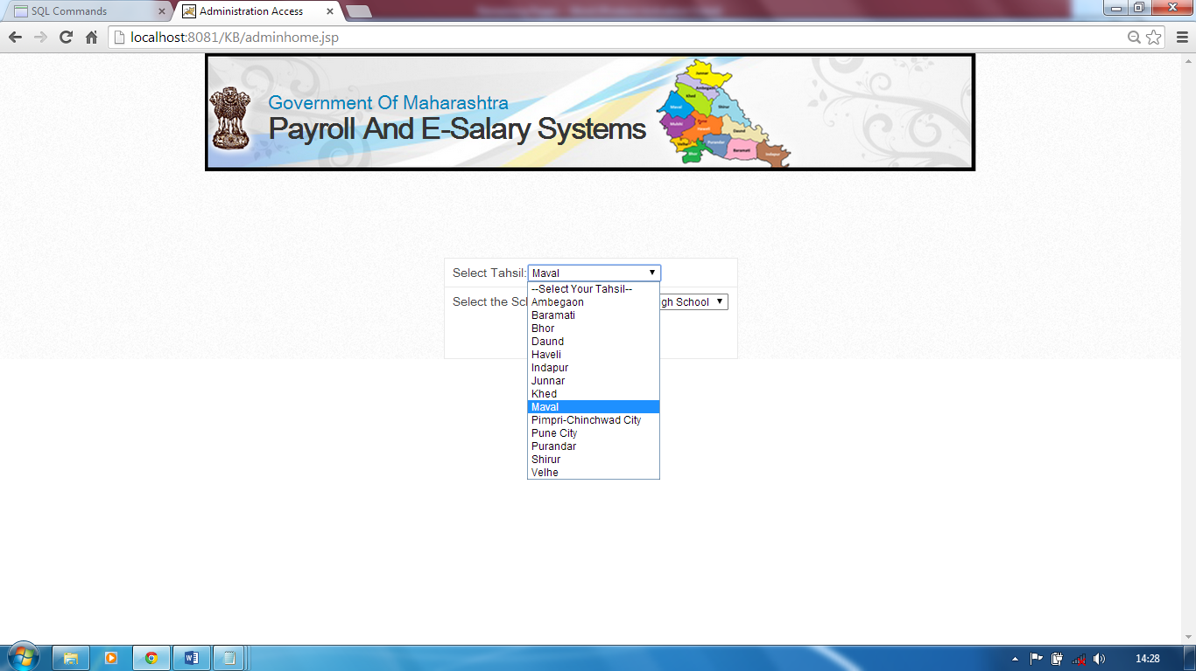

**6.10 Admin Homepage Access**

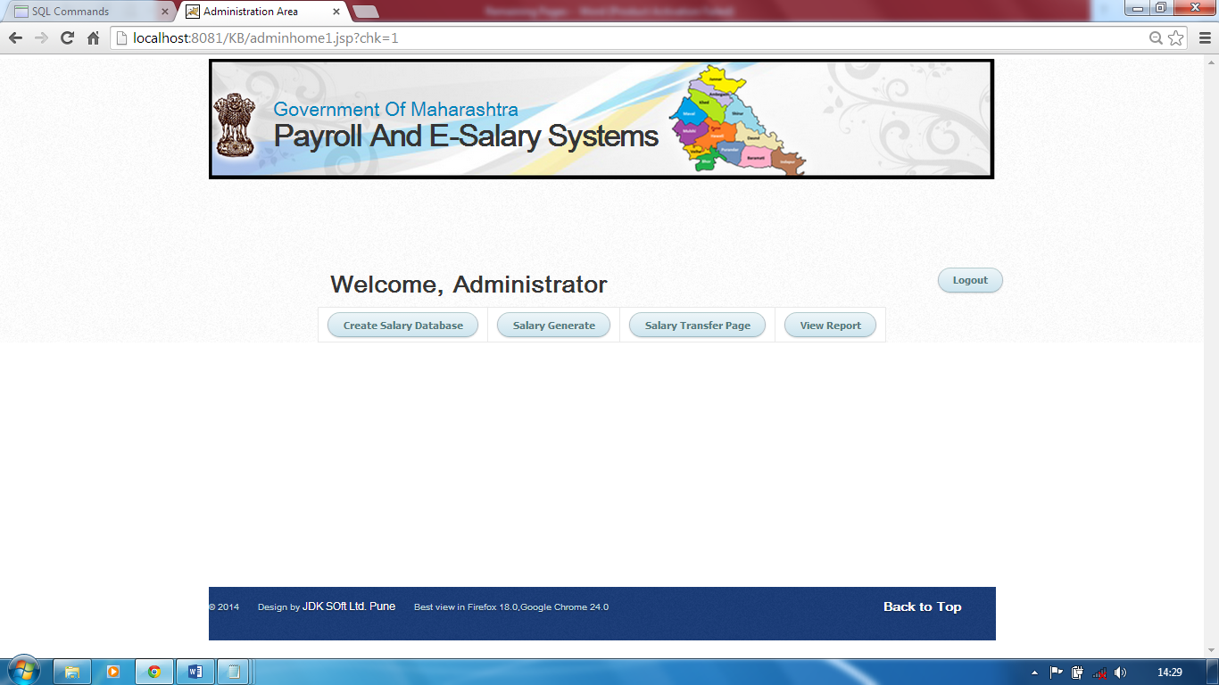

**6.11 Admin Creates Salary Database**

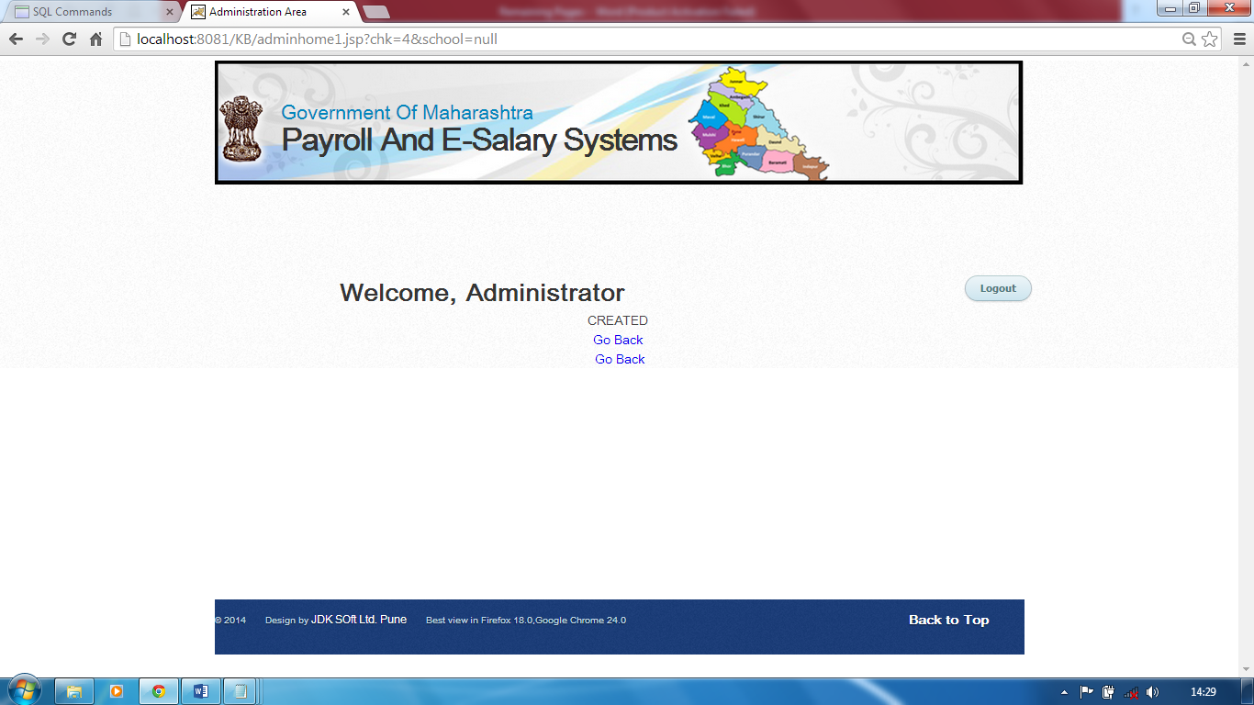

**6.12 Admin Generates Salary**

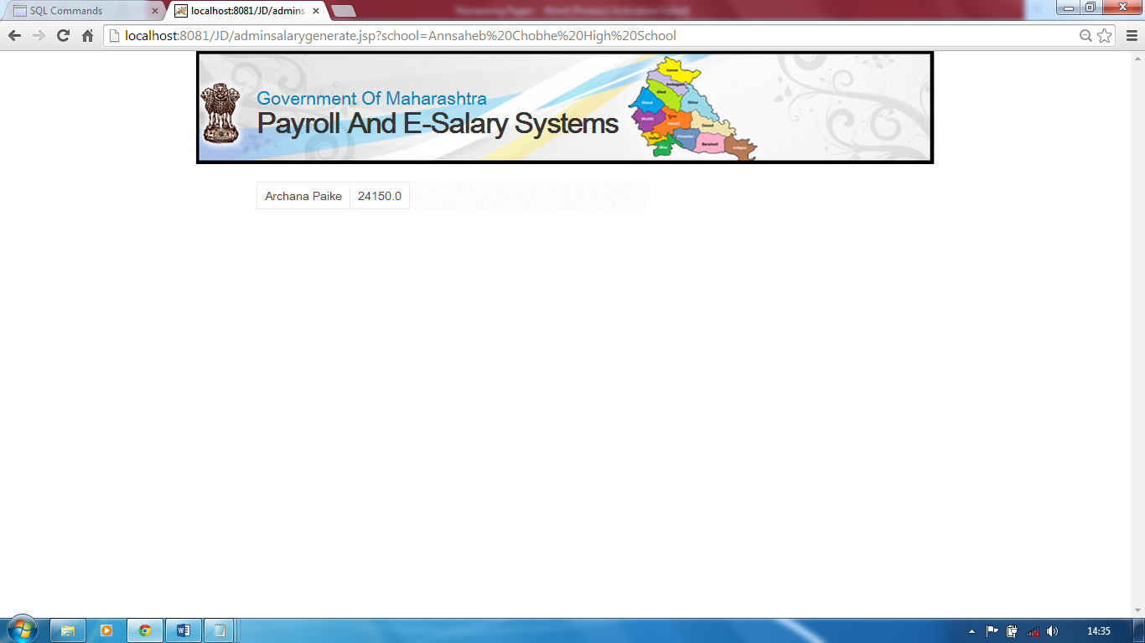

**6.13 Salary Receipt Email Sent To Teacher**

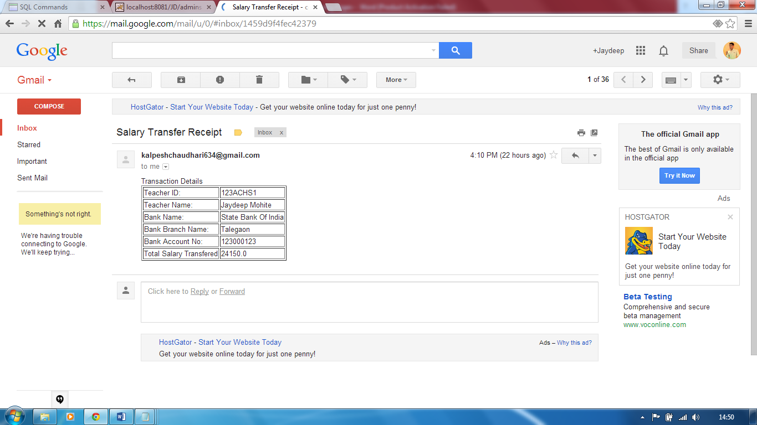

**7. Future Scope**

Our project is limited to a small division or area like Pune. In Future, our project can be expanded to over a big area covering almost the schools under the Government Of Maharashtra.

Morever our limitations to access the Internet, we haven’t included the web services and provided the gateway to transfer the salary into the respective bank accounts. We have just shown the demo transaction procedure. In future, we can implement the wen services and provide a real gateway like paypal and provide a secure transaction procedure.

Also, the website provides a limited number of features. In future additional features such as the Provident Funds, Loan Facilities can be provided to enhance the utility of the website.

Also other facilities like paper checking bills, election duty notices and bills, etc can be included in the features of the website.

**8. Conclusion**

Our project provides the website which allows the school to register, submit staff details and upload the salary details every month.

It also allows the teachers of particular school to register and then view the salary slip of particular month. Also it allows to check his/her salary status right from the inception of E-salary systems to the current date.

Our project calculates the payroll of each month online every month. Also it allow the admin to transfer the salary on first of each month.

Overall, our project is Government Website which allows or makes the salaries of Government Schools in Pune in much faster, secure, economically feasible and more importantly online through e-transaction into the particular teacher’s bank account.

**9. References**

